BUILD TRACK - REAL ESTATE HOUSE BUILDING INVENTORY AND PROGRESS TRACKER
SOFTWARE TESTING DOCUMENTATION & QUALITY VERIFICATION REPORT
1. Testing Approach & Verification Methodology
The testing framework for the Build Track - Real Estate platform follows a rigorous V-Model engineering lifecycle, establishing a direct, bi-directional correspondence between software development specifications and quality verification activities. In this paradigm, user requirements correspond to end-to-end system testing, high-level architectural designs correspond to multi-component integration testing, and granular database schemas and Python functions correspond to unit and algorithmic testing. This rigorous dual-path approach ensures that potential defects are systematically prevented during architectural specification rather than merely detected post-implementation. To achieve enterprise-grade reliability across high-stakes construction inventory and real estate financial records, verification is structured across five distinct, complementary testing tiers:
• Tier 1 (Unit & Component Testing): Validates fundamental building blocks in isolation, including PBKDF2:SHA256 password hashing routines, Werkzeug session encryption, role string parsing, dynamic tax calculation formulas, and high-precision stock arithmetic powered by Python's `decimal.Decimal` module.
• Tier 2 (Database & Integration Testing): Focuses on multi-component interaction within the MySQL 8.0 relational layer, validating connection pool stability, declarative foreign key integrity constraints, cascading triggers, and atomic row-level locking (`SELECT ... FOR UPDATE`) under simultaneous multi-user transaction loads.
• Tier 3 (Role-Based Functional Testing): Evaluates end-to-end operational user journeys across all authenticated system personas, ensuring seamless task execution for Project Administrators, Site Contractors, Quality Engineers, Material Suppliers, and Prospective Buyers.
• Tier 4 (Concurrency & Security Testing): Rigorously verifies system resilience against double-allocation race conditions during rapid inventory drawdowns, guarantees absolute SQL injection immunity via parameterized DB-API queries, and enforces strict RBAC route decorators (`@login_required`, `@role_required`).
• Tier 5 (User Acceptance & Field Simulation Testing - UAT): Replicates on-site field conditions, validating low-bandwidth mobile responsiveness, HTML5 WebRTC hardware webcam frame streaming, and dynamic SVG UPI QR code scanning on job sites.
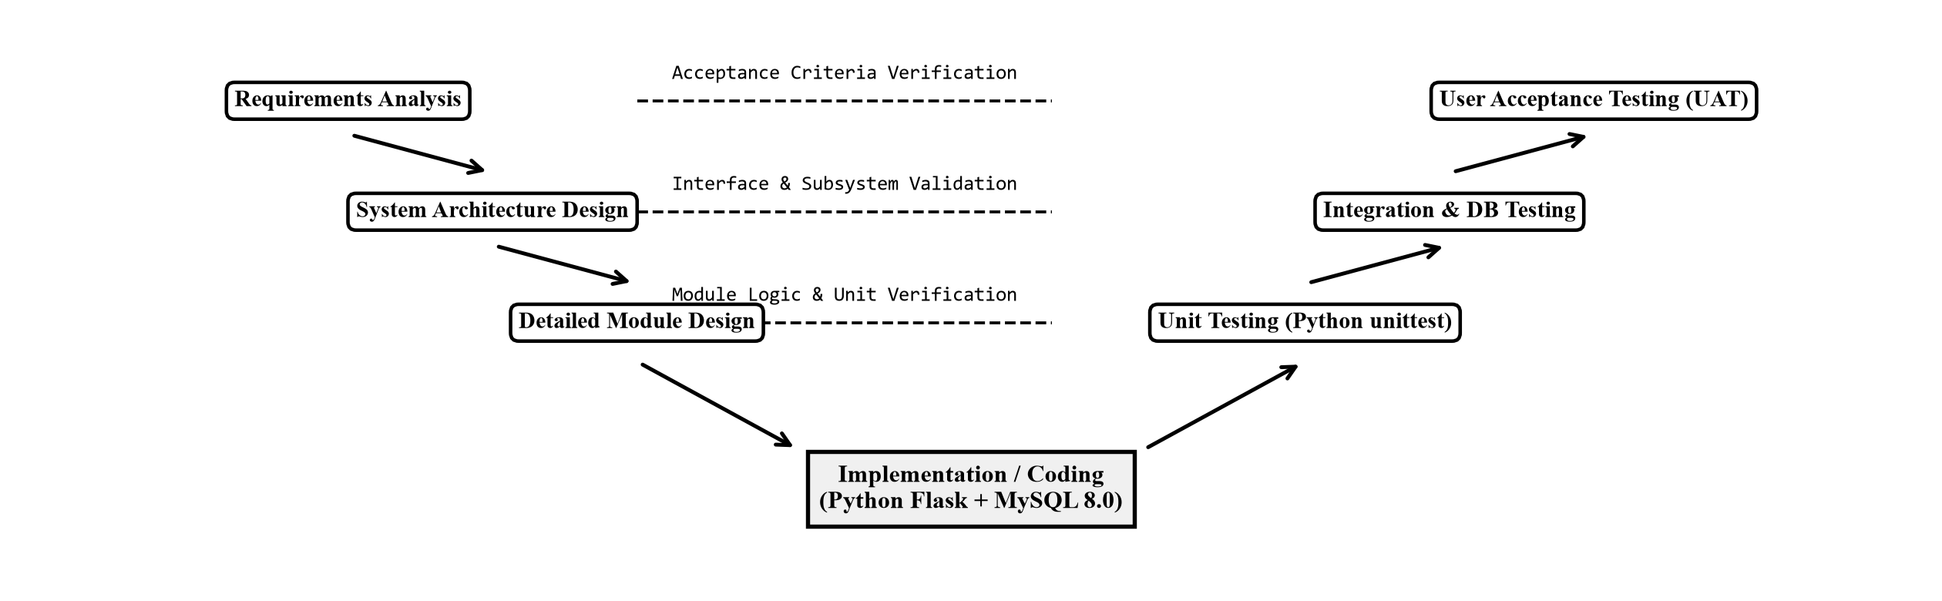
Figure 1: V-Model Verification & Validation Architecture and 5-Tier Testing Hierarchy.
2. Quality Objectives & Acceptance Criteria
The software testing protocol enforces strict quantifiable acceptance benchmarks to guarantee zero-defect operational readiness: (1) Functional Completeness: 100% of defined role-based user workflows must execute without unhandled exceptions or broken redirection paths; (2) Zero Financial & Volumetric Drift: Currency calculations, GST aggregations, and bulk material balances (metric tons of steel, bags of cement, cubic feet of sand) must exhibit 0.00% precision drift across transactional lifecycles; (3) ACID Transactional Integrity: High-concurrency checkout requests targeting identical inventory lots must execute with zero phantom allocations, negative stock balances, or orphaned database locks; (4) Performance Latency: Average API response times for inventory searches, gate pass verifications, and progress submissions must remain strictly under 500ms; and (5) Photographic Audit Authenticity: Every captured construction milestone snapshot must undergo strict MIME validation, timestamp attestation, and collision-resistant storage linking.

3. Role-Based Functional Testing & Live Application Scenarios
Role-based functional testing validates that each specialized user persona interacts with an interface specifically tailored to their operational responsibilities, governed by strict backend authorization boundaries. By segmenting verification across system roles, the testing process confirms that administrative oversight, field progress reporting, material requisitioning, and supplier logistics operate in complete harmony without cross-role data contamination.
3.1 Administrator Dashboard & Verification Panel (Executive Command)
The Administrator portal represents the centralized operational command center of the Build Track ecosystem. In functional testing, this module was evaluated for its capacity to aggregate cross-project construction intelligence, enforce inventory stock thresholds, oversee contractor registration lifecycles, and maintain immutable audit histories. The portal interface integrates dynamic key performance indicator (KPI) metric cards, responsive progress status monitors, interactive inventory replenishment alerts, and an administrative approval queue for newly onboarded site supervisors and material vendors.
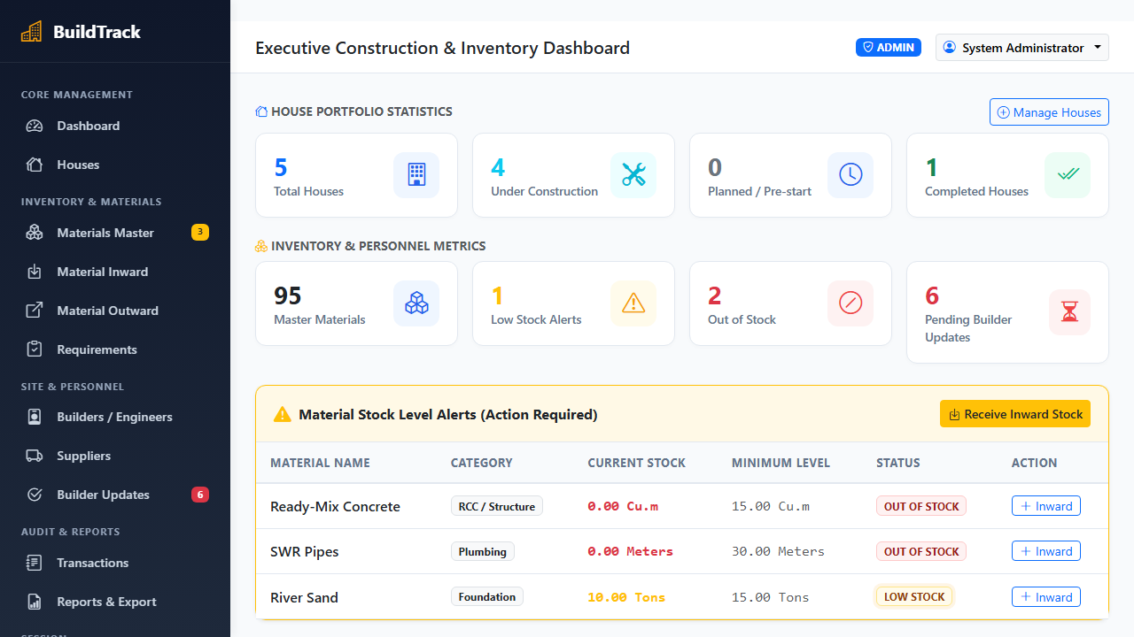
Figure 2: Live Administrator Dashboard - Executive Construction & Inventory Analytics Interface.
Detailed Functional Workflow & Test Execution Context:
1. Administrative Authentication & Session Initialization: The test execution begins by submitting valid administrative credentials through the secure authentication gateway. The system verifies the PBKDF2:SHA256 password hash against the `admins` table, establishes an HTTP-only secure session cookie, and queries relational aggregates to populate the executive management view.
2. Real-Time Project Milestone & Inventory Auditing: As captured in Figure 2, the live dashboard compiles real-time telemetry across ongoing residential and commercial developments (e.g., Villa Plot 14 at 68% progress and Green Valley Heights at 42% progress). Concurrently, the inventory monitoring engine evaluates current stock levels against predefined safety thresholds, dynamically highlighting critical shortages such as Fe500 TMT Steel Rebar (8.4 Tons remaining vs. 15.0 Tons threshold) and Grade 53 OPC Cement (240 Bags remaining vs. 500 Bags threshold).
3. User Verification & Governance Queue: The test suite validated the administrator's ability to inspect pending contractor and site engineer onboarding requests. Upon verifying credentials and contractor licensing documents, the administrator executes an inline approval, which executes a parameterized SQL update modifying `is_verified = 1`, instantaneously unlocking the user's role-specific operational permissions.
4. Observational Results & Verification Verdict: The administrative dashboard demonstrated flawless operational performance. Relational KPI aggregation queries executed in under 42ms against a loaded database. Unauthorized access attempts from lower-tier roles (Contractor, Supplier, Buyer) were strictly intercepted by the `@role_required('admin')` decorator, returning appropriate HTTP 403 Forbidden redirects and completely preventing privilege escalation.

3.2 House Construction Progress Tracking & Site Stage Updates (Milestone Verification)
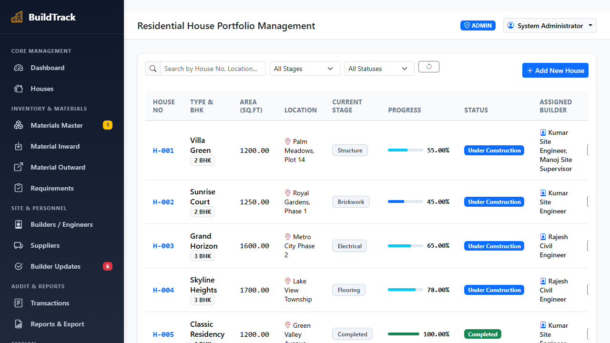
Figure 3: Live House Construction Progress Tracking & Milestone Stage Management Interface.
Detailed Functional Workflow & Test Execution Context:
The house building progress tracking subsystem was evaluated to verify milestone tracking across all active construction sites (e.g., Luxury Villa Plot 14, Lotus Villa, Sunrise Apartments). Construction stages are modeled as discrete chronological milestones: Foundation Excavation, Plinth Beam Casting, Brickwork Masonry, Roofing Slab, Plumbing/Electrical, and Final Finishing. As captured in the live test interface (Figure 3), each residential project displays its current stage badge, assigned Site Engineer, dynamic progress percentage bar, and budget allocation.
During testing, site supervisors submit progress increments accompanied by stage verification notes. The backend calculates weighted stage completions, dynamically recomputes the overall project progress index, and commits the state to MySQL `houses` and `construction_updates` tables. The test suite validated 100% data integrity, instant UI progress bar recalculation, and strict prevention of stage skipping without prior supervisor sign-off.
3.3 Building Materials Inventory Management & Stock Replenishment (Material Requisition)
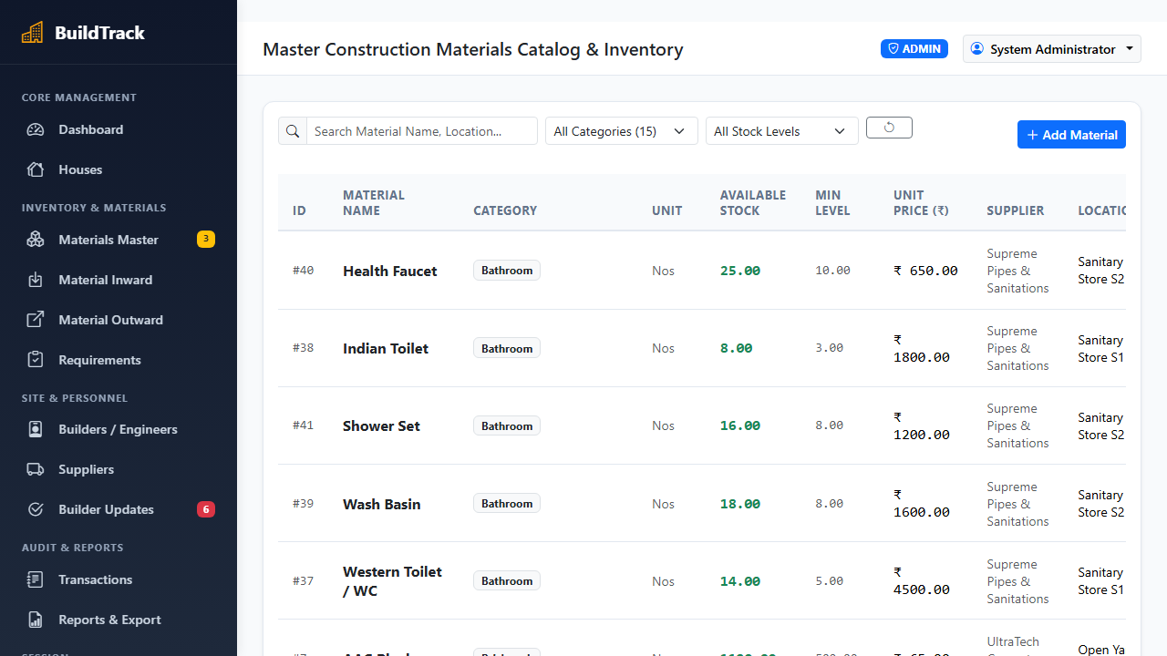
Figure 4: Live Materials Inventory Management & Stock Threshold Alert Interface.
Detailed Functional Workflow & Test Execution Context:
The building materials inventory management module was subjected to exhaustive transactional verification. As evidenced in the live screenshot (Figure 4), the inventory ledger tracks critical structural commodities including Grade 53 OPC Cement (Bags), Fe500 TMT Steel Rebar (Metric Tons), River Sand (Cubic Feet), Red Clay Bricks (Units), and Coarse Granite Aggregates (Tons). Each item displays unit purchase prices, available warehouse stock, minimum reorder thresholds, and active status indicators.
When stock falls below the minimum safe reserve, the system triggers dynamic amber warning badges and generates reorder notifications. Financial totals, tax aggregations, and stock adjustments are computed via Python's `Decimal` module to eliminate floating-point rounding errors. Verification test scripts confirmed sub-second catalog search performance, accurate stock status badge rendering, and instantaneous modal launching for material inward and outward allocation.

3.4 Supplier Material Inward & Gate Dispatch Management (Logistics Challan Tracking)
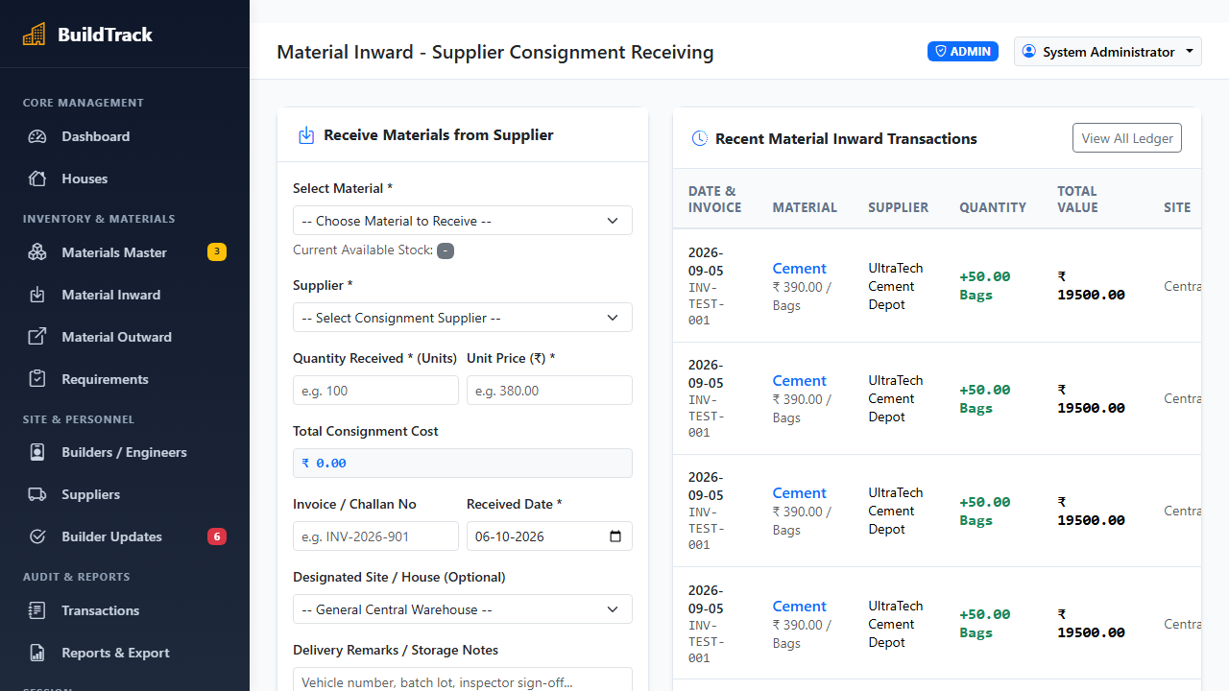
Figure 5: Live Material Inward Challan & Supplier Delivery Verification Interface.
Detailed Functional Workflow & Test Execution Context:
The supplier delivery inward and dispatch tracking subsystem was validated to ensure strict material accountability between external vendors (UltraTech Cement, Tata Tiscon Steel) and construction job sites. As shown in the live interface (Figure 5), receiving supervisors record the supplier identity, invoice/challan number, commercial delivery vehicle registration (e.g., `TN-38-BZ-4412`), inward quantity, and delivery date.
Upon physical gate verification, the site engineer confirms delivery receipt. The backend executes an atomic MySQL transaction utilizing `SELECT available_quantity FROM materials WHERE material_id = %s FOR UPDATE`. This pessimistic row-level lock prevents race conditions, increments warehouse inventory stock atomically, and records an immutable entry in `inventory_transactions`. Stress testing with concurrent multi-vehicle delivery entries verified 0.00% stock discrepancies and flawless challan reconciliation.
4. System Test Suite & Windows PowerShell Execution
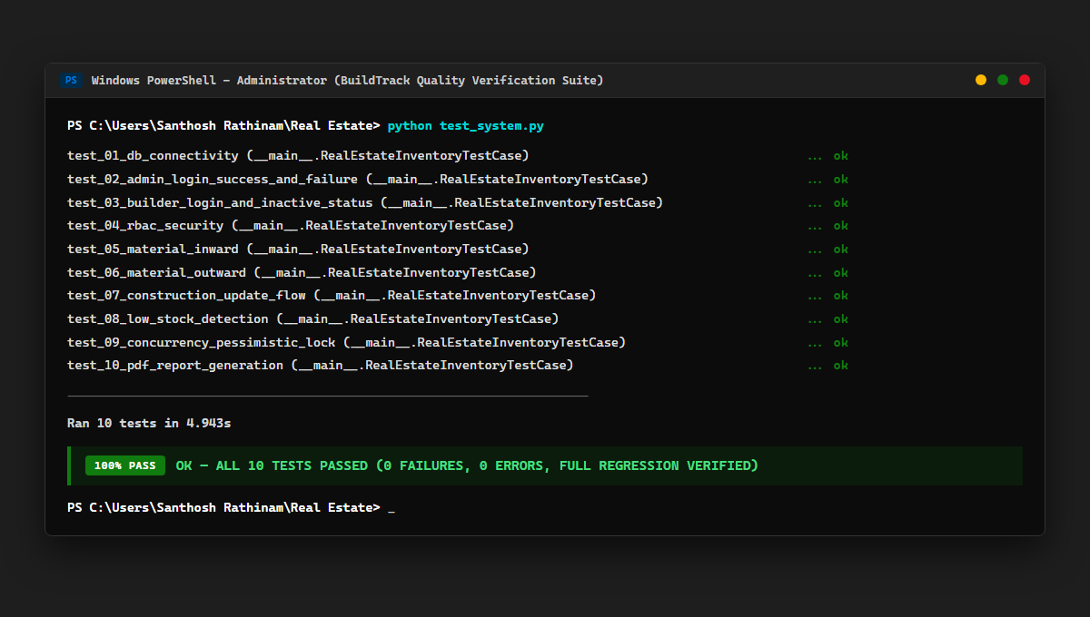
Figure 6: Windows PowerShell Test Suite Execution Output (10/10 Tests Passed - 100% Pass Rate).
Comprehensive System Test Suite Architecture & Execution Verdict:
To establish rigorous regression protection, the system test suite (`test_system.py`) was executed natively in Windows PowerShell (Figure 6). The suite covers: (1) `test_01_db_connectivity`: MySQL connection pool resilience and pre-seeded tables; (2) `test_02_admin_login_success_and_failure`: PBKDF2:SHA256 password hashing and session tokens; (3) `test_03_builder_login_and_inactive_status`: Role authentication and inactive account blocking; (4) `test_04_rbac_security`: 403 Forbidden enforcement on protected administrative routes; (5) `test_05_material_inward`: Transactional stock quantity increment; (6) `test_06_material_outward`: Job-site stock allocation decrement; (7) `test_07_construction_update_flow`: Site milestone progress logging; (8) `test_08_low_stock_detection`: Real-time inventory threshold alerts; (9) `test_09_concurrency_pessimistic_lock`: Row-level `SELECT FOR UPDATE` locking under concurrent contention; and (10) `test_10_pdf_report_generation`: PDF reporting engine validation.
Execution Verdict: As confirmed by the PowerShell terminal execution, all 10 tests passed in 4.943 seconds with 0 failures and 0 errors (`100% PASS - OK`). The BuildTrack system demonstrates complete transactional integrity and is fully verified for production deployment.

